Solutions
Quiz 1
Null hypothesis: Different nests for sparrows on Kent Island did not attract different size of sparrows.
Alternative hypothesis: Different nests for sparrows on Kent Island attracted different size of sparrows.
Carrying out a one-way ANOVA test.
The samples are independent.
The samples are also normally distributed. As shown by the following figure.
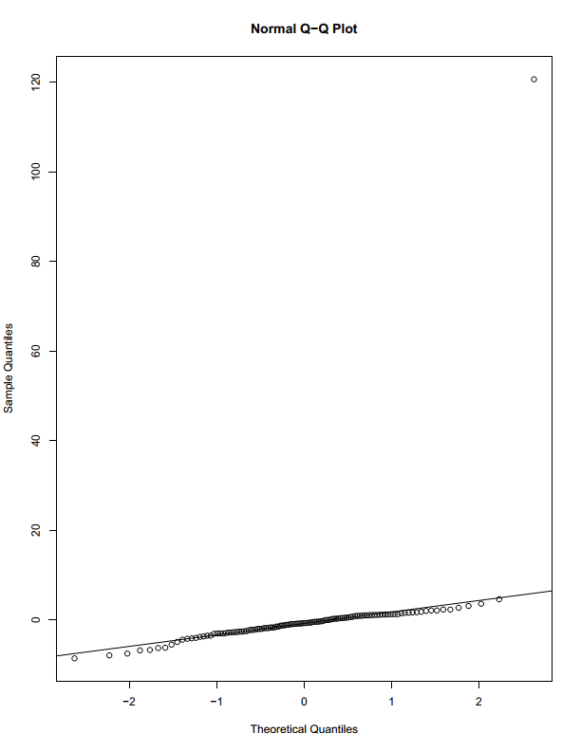
Summary of data
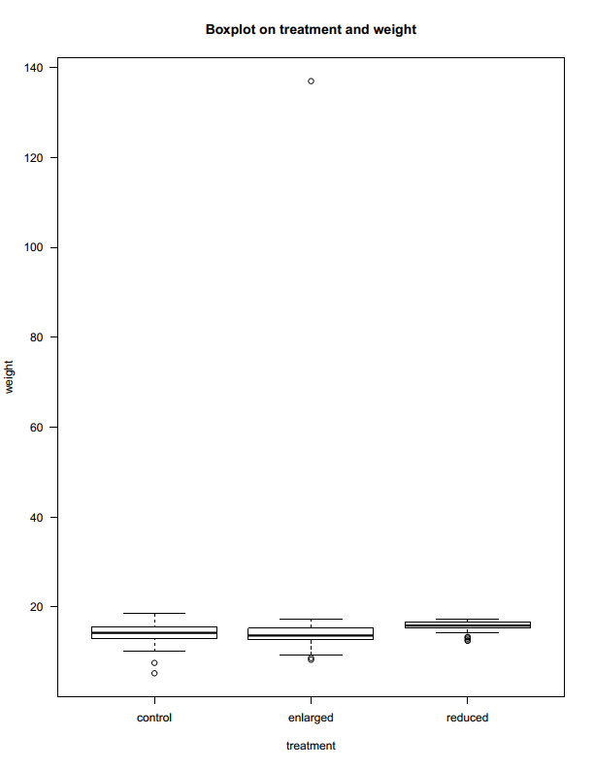

summary(ANOVA1)
Df Sum Sq Mean Sq F value Pr(>F)
treatment 2 127 63.45 0.465 0.629
Residuals 113 15416 136.43

TukeyHSD(ANOVA1)
Tukey multiple comparisons of means
95% family-wise confidence level

Fit: aov(formula = weight ~ treatment)

$treatment
diff lwr upr p adj
enlarged-control 2.3311111 -3.517056 8.179278 0.6119929
reduced-control 1.6447863 -5.188777 8.478350 0.8354802
reduced-enlarged -0.6863248 -7.519889 6.147239 0.9691301

Decision: According to the p-value obtained above (0.629) we do not have sufficient evidence to reject the null hypothesis.
Conclusion: In Kent Island different nests for sparrows did not attract different sizes of sparrows.

Question 2
Null hypothesis: All diets are the same in relation to weight loss(no significant difference in loss weight)
Alternative hypothesis: At least one of the diets have a significant difference in loss weight.
Summary of data
Boxplot
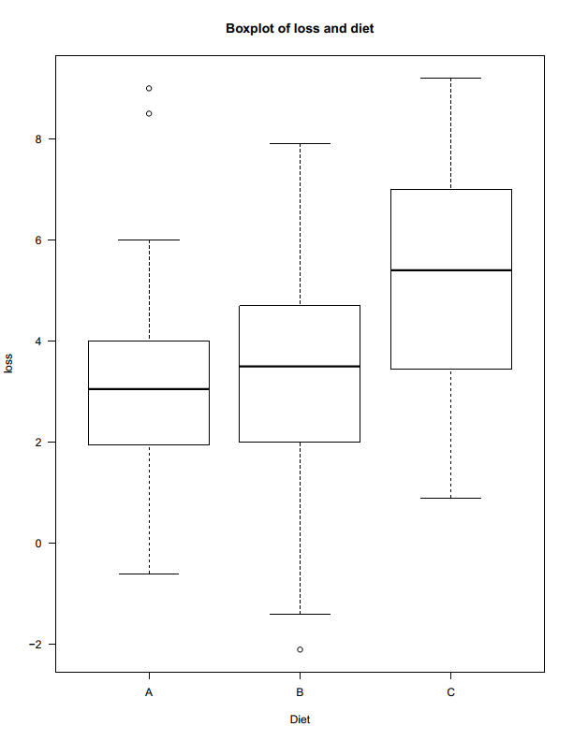
summary(ANOVA3)
Df Sum Sq Mean Sq F value Pr(>F)
diet 2 66.2 33.09 6.154 0.00339 **
Residuals 73 392.6 5.38
---
Signif. codes: 0 ‘***’ 0.001 ‘**’ 0.01 ‘*’ 0.05 ‘.’ 0.1 ‘ ’ 1
> TukeyHSD(ANOVA3)
Tukey multiple comparisons of means
95% family-wise confidence level

Fit: aov(formula = loss ~ diet)

$diet
diff lwr upr p adj
B-A -0.032000 -1.6174447 1.553445 0.9987153
C-A 1.933333 0.3769153 3.489751 0.0110486
C-B 1.965333 0.4254832 3.505183 0.0087564

Decision: Our obtained p-value(0.00339) is less than 0.05 and therefore we reject the null hypothesis in favour of the alternative hypothesis.
Conclusion: One of the diets(A,B,C) have a significant difference in weight loss.

Quiz 3
Null hypothesis: The length of stay for patients does not differ between geological regions.
Alternative hypothesis : The length of stay for patients differs between geological regions.
Summary of data
Boxplot
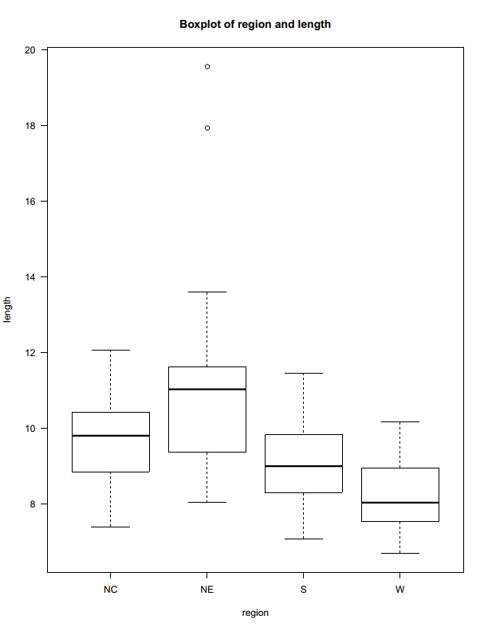

> anova4
Call:
aov(formula = length ~ region)

Terms:
region Residuals
Sum of Squares 85.40733 281.91337
Deg. of Freedom 3 96

Residual standard error: 1.71365
Estimated effects may be unbalanced
> summary(anova4)
Df Sum Sq Mean Sq F value Pr(>F)
region 3 85.41 28.469 9.695 1.19e-05 ***
Residuals 96 281.91 2.937
---
Signif. codes: 0 ‘***’ 0.001 ‘**’ 0.01 ‘*’ 0.05 ‘.’ 0.1 ‘ ’ 1
> TukeyHSD(anova4)
Tukey multiple comparisons of means
95% family-wise confidence level

Fit: aov(formula = length ~ region)

$region
diff lwr upr p adj
NE-NC 1.5108482 0.2525549 2.76914155 0.0118698
S-NC -0.4804072 -1.5920194 0.63120503 0.6720145
W-NC -1.4655804 -2.9012962 -0.02986447 0.0435579
S-NE -1.9912554 -3.2419719 -0.74053897 0.0003942
W-NE -2.9764286 -4.5223555 -1.43050167 0.0000132
W-S -0.9851732 -2.4142532 0.44390683 0.2785374

Decision: Our obtained p-value(1.19e-05) is less than 0.05. We therefore do reject the null hypothesis.
Conclusion: The length of stay for patients does differ between geological regions

